**VPC:**

* CIDR
* Subnets
* Internet Gateway (IGW)
* Route Tables
* IP’s (Private, public , Elastic)
* NAT Gateway

**Firewalls:**

* Security Groups
* NACL

**Private Connectivity Options:**

* VPC Peering
* VPC Endpoint gateway
* VPC private link
* VPC Connection
* Direct connect

**DNS Management:**

* Route 53

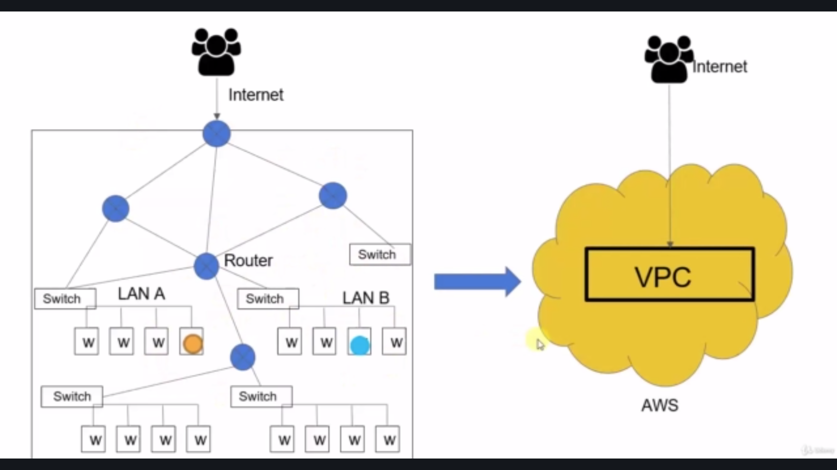

**VPC:**

Amazon Virtual Private Cloud (Amazon VPC) enables you to launch AWS resources into a virtual network that you've defined.

This virtual network closely resembles a traditional network that you'd operate in your own data center, with the benefits of using the scalable infrastructure of AWS.

**Subnets:**

When we divide the VPC into Smaller network it can be referred to as subnets.

**Internet GateWay:**

VPC connects with the internet using Internet gateway (IGW).

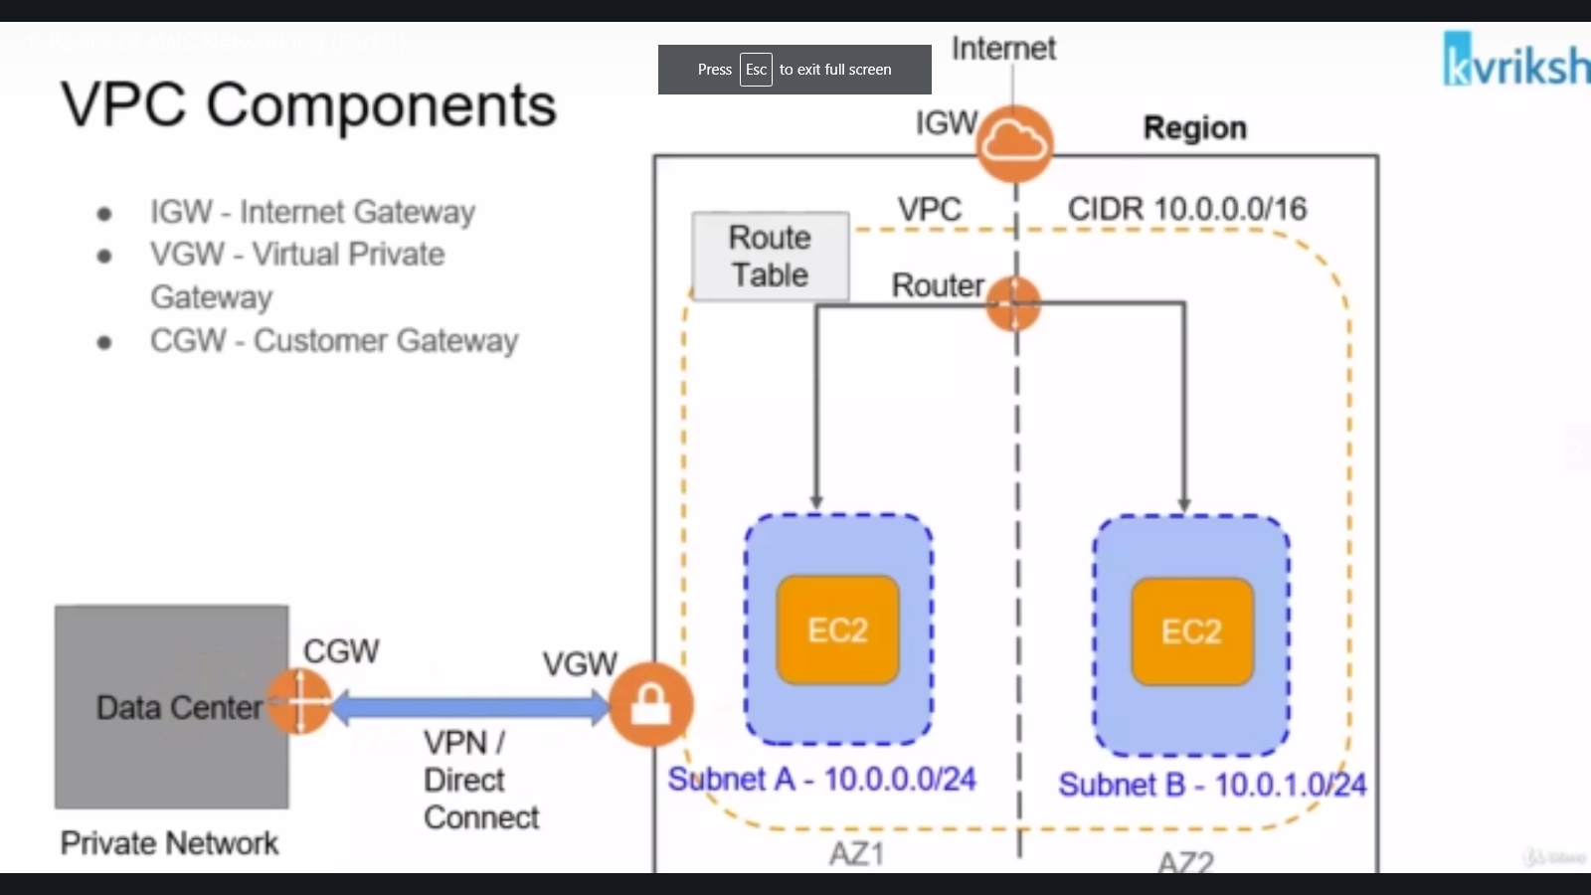

Virtual private gateway & Customer gateway are used to connect with Data center and VPC

**CIDR:**

Classless Inter-Domain Routing is a set of Internet protocol (IP) standards that is used to create unique identifiers for networks and individual devices

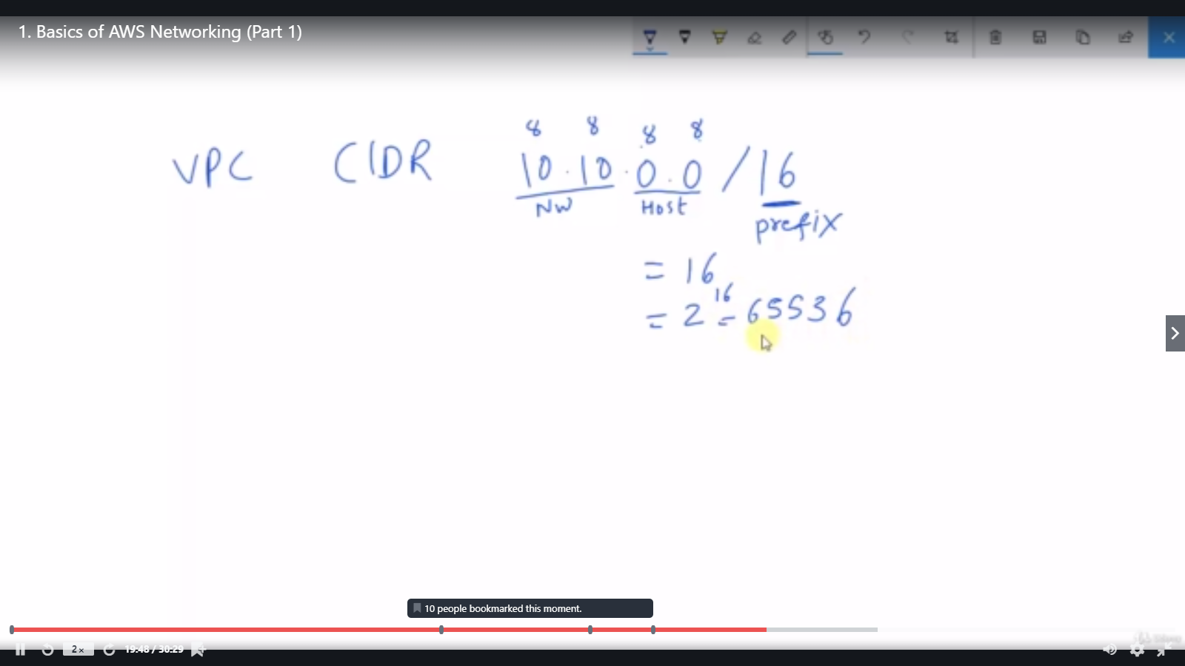

In the above image, 10. 10 . 0 . 0 /16 means

* first 16 bits are assigned to network and
* Second 16 bits are assigned to the host.

Which means ,

We can have 2 to the power of 16 - 65536 ip addresses. Below given image shows the calculation of the host IP’s

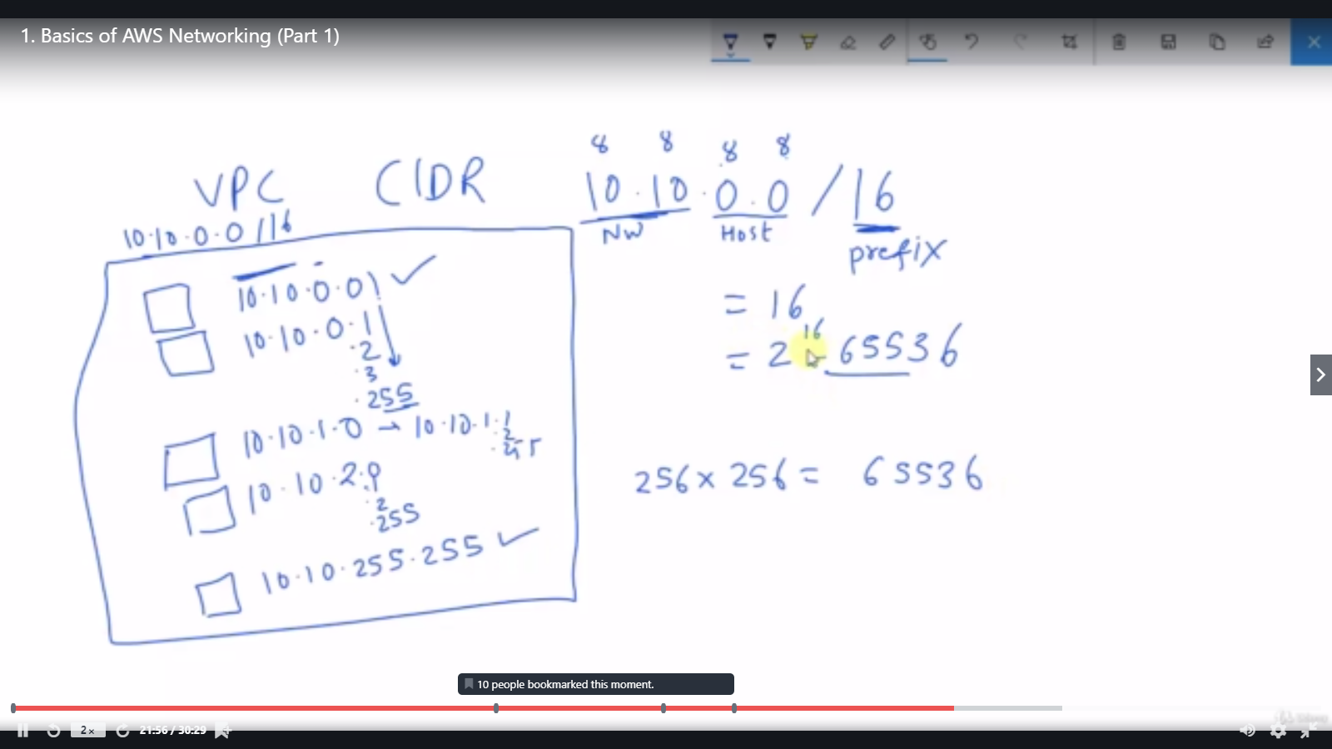

----------------------------------------------------------------------------------------------------

For example, consider the below image

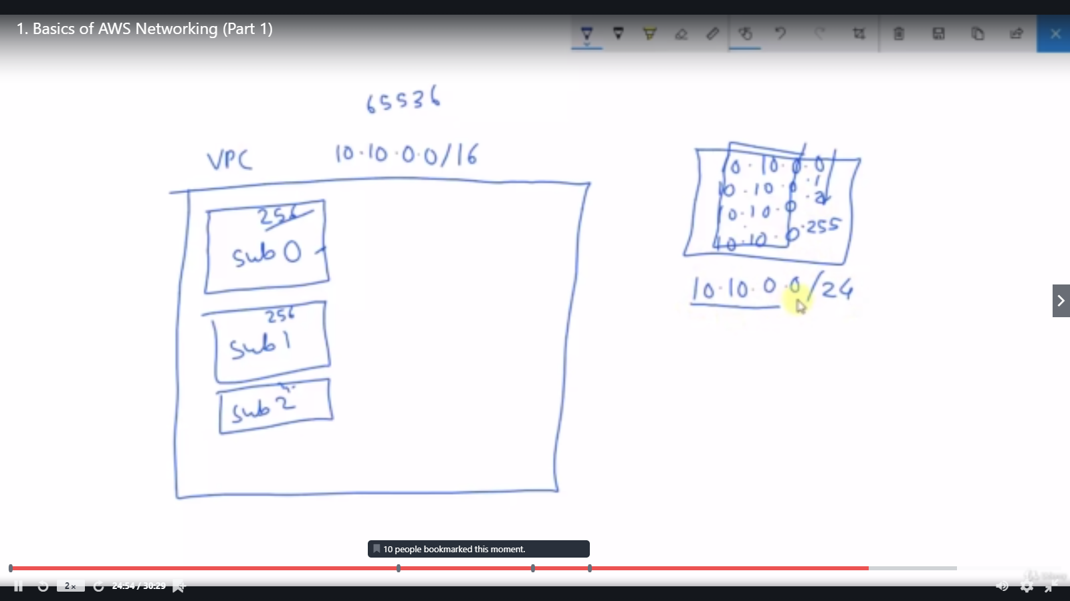

* I have created a VPC with the CIDR rage of 10 . 10 . 0 . 0 /16
* I have to create three subnets.
* I want the total number of ip in the first address to be 256.
  + Hence if i declare 10 . 10 . 0. 0/24
  + The first 24 bits are assigned to the network. Remaining 8 bits are assigned to IP
  + Hence 2 to the power of 8 is 256
* Summary is the first 24 bits are used to identify the network and the last 8 bits (256 ip’s ) are assigned to hosts.

So , with this, if we have the CIDR range as , then we can create the subnets as mentioned below

